FINAL REPORT
INTRODUCTION TO PROJECT:
The project is about to designing a web page for “gym management system”. A health fitness centre or gym is a place that has the equipment for the purpose of exercise or sports activities. It is also called fitness centre or fitness club. The word gym as used today is a contraction of word Gymnasium.
PARTS DONE BY STUDENTS:
VISHAL MISHRA : Icons are designed(face book,twitter,…).
KALAISELVAN : Main headings are designed(training,time table,….).
SURESH RAM : boxes with headings are designed.
TAGS USED IN PROJECT:
TITLE tag, link tag, division tags, body tag, head tag, <li> tag, <ul> tag,
IMAGE tag, <h> tag, <i> tag, html tag.
SCREEN SHOTS OF PROJECT:
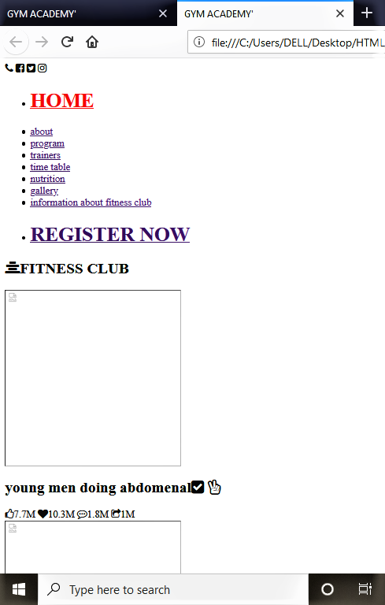
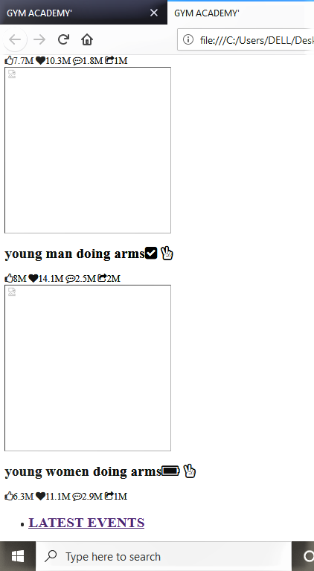
SEC:K19GR GROUP:06
NAME REG.NO ROLL NO.
VISHAL MISHRA 11908798 A16
KALAISELVAN K 11908852 A17
R.SURESH RAM 11908772 A18

